Game Design Document
Fill up the following document

- Write the title of your project.
1. The title of the of the game is LASER MAN .

- What is the goal of the game?
2. The goal of the game is to laser man should kill villain robots that are roaming in sky .

- Write a brief story of your game.
3. One day some of the space ships came they released some robots which started attacking on earth . Laser Man should stop them .

- Which are the playing characters of this game?
- Playing characters are the ones who respond to the user based on the input from the user.
- Cars, monkeys, dinos, wizards, etc., are the playing characters in the game.

Number | Character Name | What can this character do?
1 | LASER MAN | He shoots laser bullet to kill ROBOTS.
2 | ROBOTS | it shoot fire to kil LASER MAN
3 | N/A | N/A
4 | N/A | N/A
5 | N/A | N/A
6 | N/A | N/A
7 | N/A | N/A
8 | N/A | N/A

- Which are the Non-Playing Characters of this game?
- Non-Playing characters are the ones that don't have an action or behavior when the user interacts with the game.
- Hurdles, stones, bananas, coins, etc., are non-playing characters in the game.

Number | Character Name | What can this character do?
1 | Power balls | When LASER MAN touches it then power balls give power to shoot more laser bullets .
2 | N/A | N/A
3 | N/A | N/A
4 | N/A | N/A
5 | N/A | N/A
6 | N/A | N/A
7 | N/A | N/A
8 | N/A | N/A

Draw your imagination of this game. What does this game look like?
- Draw the game either on your computer or on paper.
- Add images of the game scenes to show each of the playing and non-playing characters at least once.
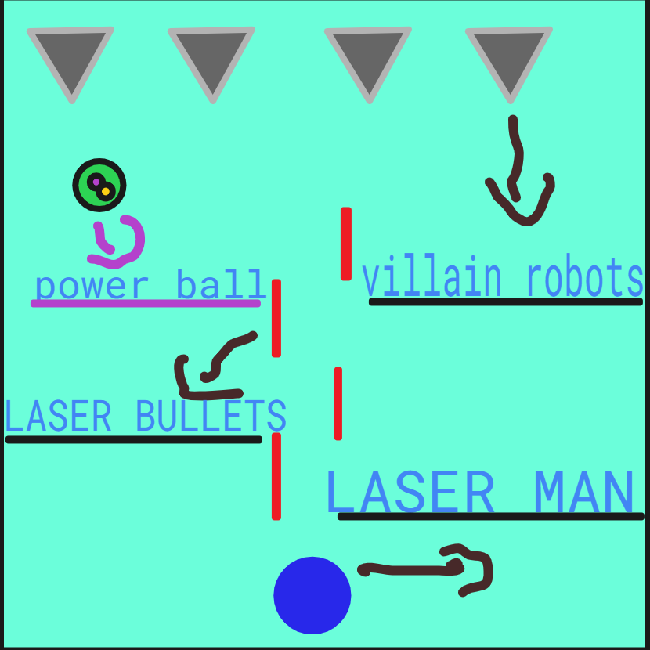

How do you plan to make your game engaging?

Ans. My game has a Laser Man , robot and power ball . Laser Man is the hero of the earth . In the game laser man will save earth from robots . In the game robots had attacked on earth . In the game power ball makes laser man's laser bullets quantity more
this makes my game more engaging.

